Name: _________________________
Math Homework

Monday 2/27
Look at the granola bar:  What fraction of the granola bar has been eaten? | Look at the granola bar:  What fraction of the granola bar has been eaten?
Frankie’s sold 8 pizzas every night for a week. How many pizzas did Frankie’s sell?

Tuesday 2/28
How far from zero is the location marked with a star? | How far from zero is the location marked with a star?  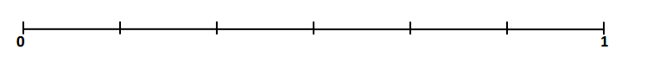
Circle the pictures that accurately represent thirds.

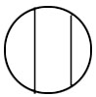
Explain your reasoning:

Wednesday 3/1
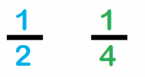Circle the bigger fraction: | Circle the bigger fraction:
Explain how you know: | Explain how you know:
Jessica has 7 five dollar bills. Jessica’s older brother has 5 ten dollar bills and 3 one dollar bills. Who has the most money?

Thursday 3/2
Partition the number line into fourths. Then, partition the number line into eighths. | Partition the number line into thirds. Then, partition the number line into sixths.
Explain your thinking: How did you partition the number line?

